#### **PHYSICS 12 – Electricity and Magnetism Topic Test 1 2019**

#### **Question/Answer Booklet**

**NAME: ____________________________________**

**TIME ALLOWED FOR THIS PAPER**

Working time for paper: 45 minutes

**STRUCTURE OF THE PAPER**

|  |  |  |  |  |
| --- | --- | --- | --- | --- |
| Section | No. of questions | No. of questions to be attempted | No. of marks out of 44 | Approximate Proportion of test total |
| A: Short Answers | 4 | ALL | 11 |  |
| B: Problem Solving | 4 | ALL | 33 |  |
|  |  |  |  |  |

**Section A: Short Answer**

Marks Allocated: 11 Marks out of 44 total

This section has 4 questions answer the questions in the spaces provided

________________________________________________________________________

**Questions 1 [3 marks]**

Draw the magnetic fields around each single current carrying conductor.

(a)

[1 mark]



(b)

[1 mark]



(c) If these two current carrying conductors were placed close together as shown below, what would be the effect of the two fields on each other? Circle the correct response

[1 mark]

 

Attraction Repulsion No effect

**Question 2 [3 marks]**

In the diagram opposite, RS is free to move. How will RS move if the switch is closed? Circle the correct response.

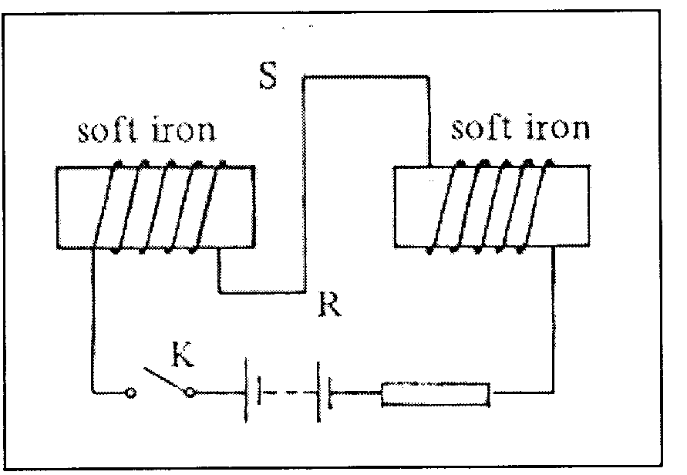

A rotate

B into the paper

C out of the paper

D downward

E upward

**Explain your choice**

**QUESTION 3 [3 marks]**

Two point electric charges are separated by a certain distance and experience a repulsive force of magnitude F. If the distance between them is reduced to one third of its previous value, and one of the charges is now doubled, calculate the magnitude of the new force, in terms of F.

**Question 4 [2 marks]**

## Y

X

The magnetic fields from two different sources (X and Y) are shown above. If these two fields were overlapped, which diagram below most accurately represents the resultant field?

A. B. C. D.

ANSWER: ________

**Section B: Problem Solving**

Marks Allocated: 33 Marks out of !! total

This section has 4 questions answer the questions in the spaces provided

________________________________________________________________________

**QUESTION 5 (9marks)**

The rectangular coil shown below is to be used in a small electric motor in a toy. The coil has 100 turns of wire and each turn is rectangular with sided 0.04 m and 0.02 m as shown. The magnetic flux density is constant through the coil at 0.06 T.

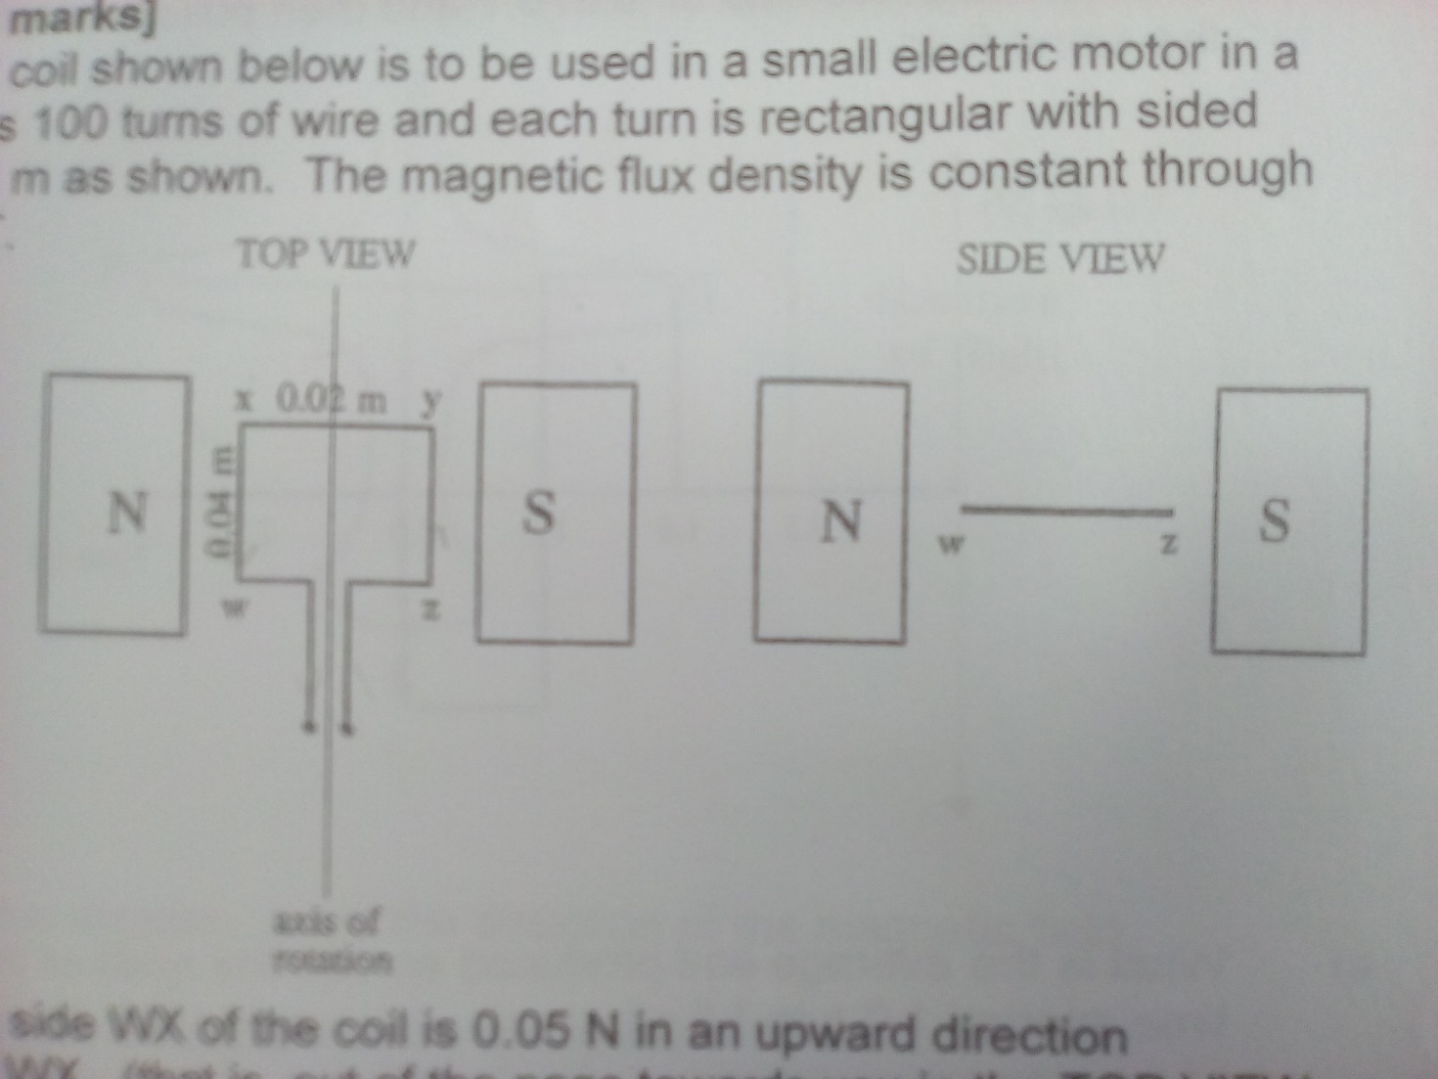

**(SCAN PROPERLY)**

The force on the side WX of the coil is 0.05 N in an upward direction perpendicular to WX. (that is, out of the page towards you in the TOP VIEW of the coil)

1. Indicate, on the diagram, the direction of the current in the side WX and the side ZY. (2 marks)
2. Calculate the magnitude of the current in the coil. (2marks)
3. Calculate the value of the maximum torque on the coil. (2 marks)
4. There are two positions of the coil during its motion at which the toque on the coil is zero. On the SIDE VIEW of the diagram, draw a diagram of one of these positions. (2 marks)
5. Explain how the coil is able to move when the torque on the coil is zero in each of these two positions. (2 marks)

**QUESTION 6 [8 marks]**

Two 2.00m conductor rods are placed one above the other as shown. (SCAN PROPERLY!)

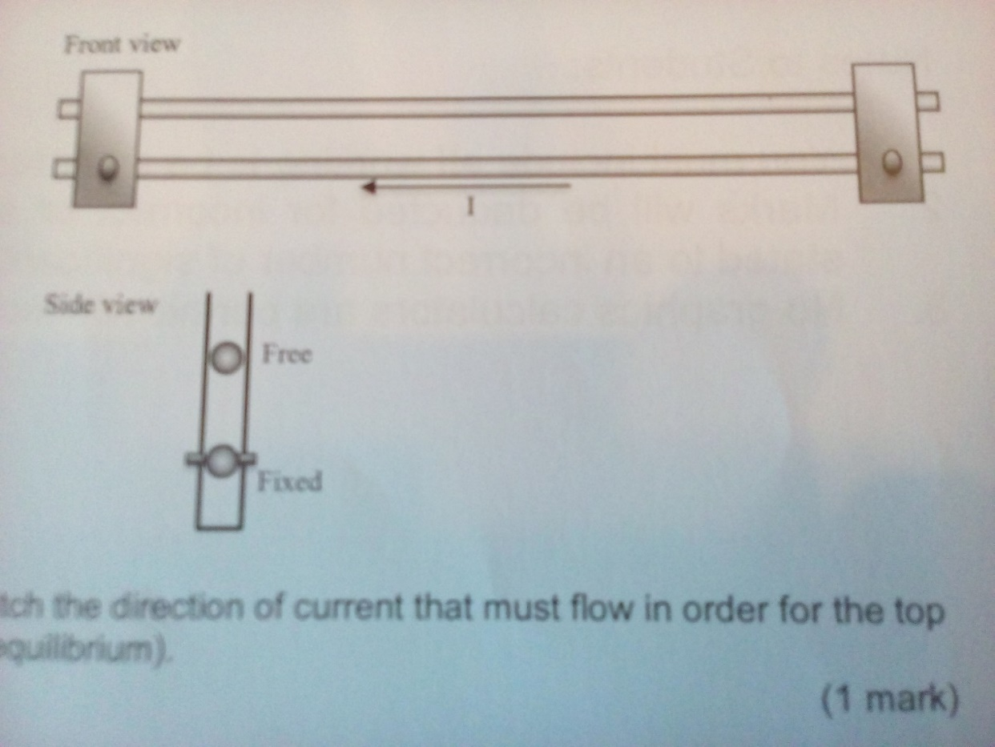

The bottom conductor is held in place by brackets and the top one is free to move up and down. Each conductor has a mass of 0.0100kg and a current of 20.0A moves through the bottom conductor for right to left as shown in the front view above.

1. On the front view diagram, sketch the direction of current that must flow in order for the top rod to levitate (remain in static equilibrium)

[1 mark]

1. Calculate the strength of the magnetic field (produced by the bottom rod) a distance of 4.00mm above the bottom rod

[3 marks]

1. Calculate the current flowing in the top rod that is necessary to suspend it 4.00mm above the bottom rod.

[4 marks]

**QUESTION 7 [9 marks]**

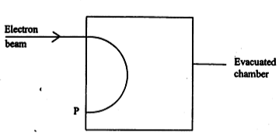A beam of electrons having energies between 10 and 100 keV passes through a slit into an evacuated chamber as shown. A magnetic field makes the electrons move in a semicircle and those with a particular velocity hit the wall at point P.

Indicate on the diagram the direction of the magnetic field that would result in the electron following this path. (2 marks)

Explain why the charged particles move in a circular motion in the direction of P. (2 Marks)

Sketch (on the diagram) the path taken by an electron a higher velocity. (1 mark)

Sketch (on the diagram) the path of a proton when fired with the same velocity into the same evacuated chamber. Briefly explain why you have sketched it this way. (2 marks)

Explain how the motion of the charged particles would change if the strength of the magnetic field was increased. (2 marks)

**QUESTION 8 [7 marks]**

An **electron beam** is fired between two metal plates which have **a potential difference** of 100 V. A **uniform magnetic field** of 0.050 T is directed parallel to the plates and at right angles to the electron beam as shown in the following diagram.

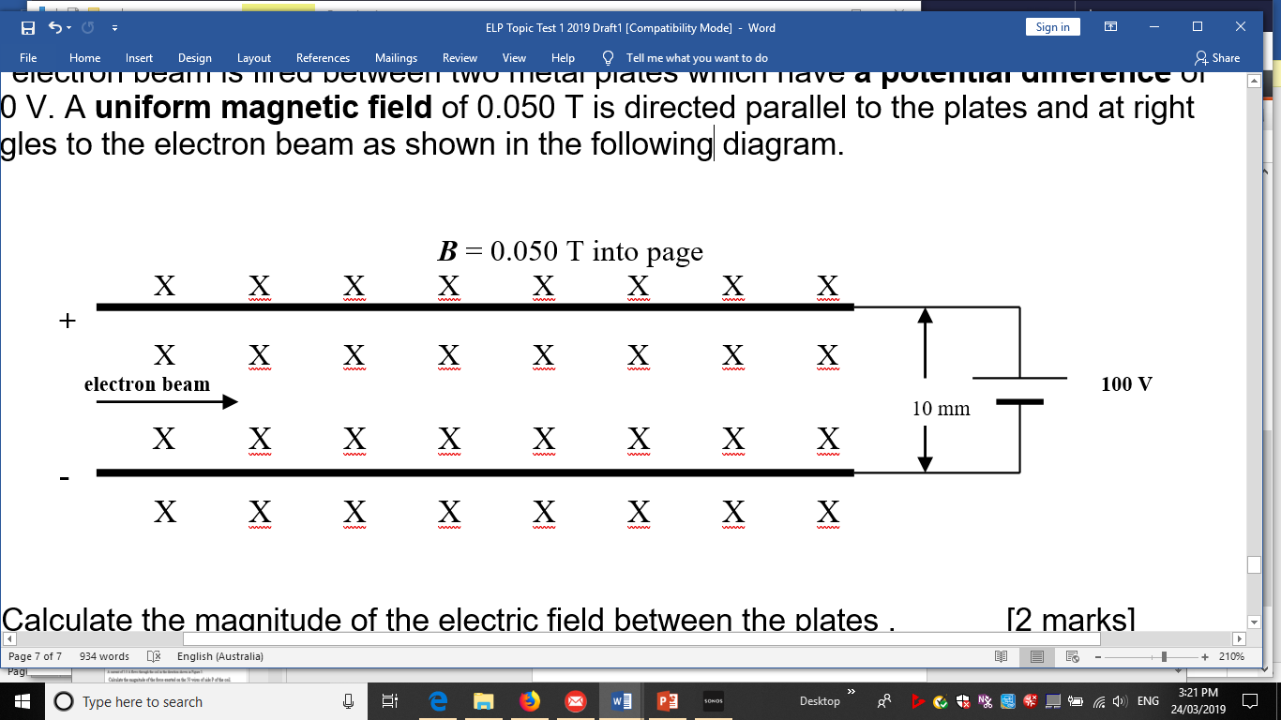

a) Calculate the magnitude of the **electric field** between the plates. [2 marks]

b) Determine the magnitude and direction of the **electrical force** acting on the electron beam. [3 marks]

c)What is the direction of the force due to the **magnetic field** on each electron? [1 marks]

d)Assuming the force due to gravity is negligible, in what situation could the electron beam pass undeflected through the plates in the magnetic field? [1 marks]